**Island of Hidden Bounty**

***Forensic***

**Challenge:**

"In a digital realm where mysteries reside,

An image conceals what you can't deride.

Navigate the web, find the clue to cite,

Unravel the flag hidden in plain sight."

Attached - blackperl.jpg

**Approach:**

An image in a forensics question? Always check for steganography.

We perform stegseek on it and get a text file which contains a link:

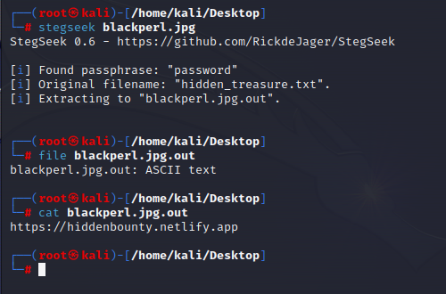

We head over to the website and see a blank website with a pirate GIF and some text.

The website contains a javascript file but that too is not useful for us.

After some going around, we check the robots.txt file and we see this another page named as:

/HiddenInMist.html

We go over to that link and…get the flag:

**Flag: QUESTCON{X_M4rk5Th3Digit4lTr34sur3}**

Congrats!!

Happy Hacking!